ANNOUNCEMENT
ABOUT THE PREQUALIFICATION PROCEDURE

This text of the announcement is approved by the decision of the evaluation committee of the two-stage competition No. 1 dated February 17, 2026 and is published
According to Article 24 of the RA Law "On Procurement"

Procedure code: ՀՀ-ԱՄ-ԱՀ-ԵՄԱՊՁԲ-07/26

I. DESCRIPTION OF THE PURCHASE ITEM

1. The Client, Apaparan Municipality, located at 26 Baghramyan Street, Aparan, Aragatsotn Region of the Republic of Armenia, announces a pre-qualification procedure (hereinafter also referred to as the Pre-qualification Procedure) for the purpose of determining potential participants for the procurement of children's playground equipment, in accordance with the provisions of Article 15, Part 6, Clause 1 of the RA Law "On Procurement" and in accordance with the procedure established by Parts 1 and 2 of Article 19.
1.1 The products purchased under this procedure must be factory-made, have appropriate certificates and comply with the laws and legal acts in force under the legislation of the Republic of Armenia. Moreover, in case of presenting products of a Factory located outside the Republic of Armenia, the Selected Participant must submit an official written confirmation from the Factory producing the products purchased under this procedure that the given Factory has an official representative office in the Republic of Armenia and a technical service center for the products purchased under this procedure.

Size  number | Naming | Unit of measurement | Quantity | Appearance
1 | Attraction Autodrome | piece | 1 | 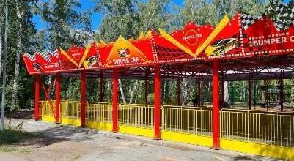  
2 | Attraction  Manege | piece | 1 |   
3 | Amusement Park | piece | 1 | 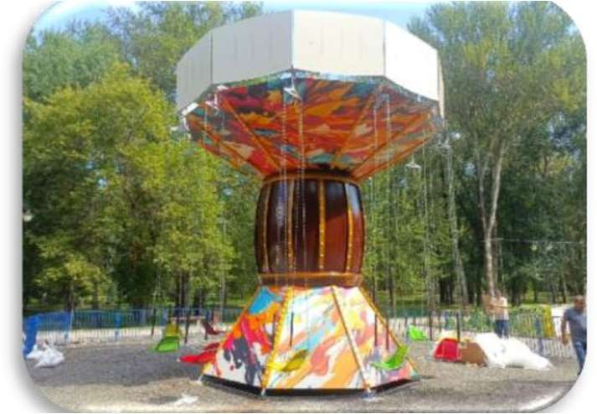  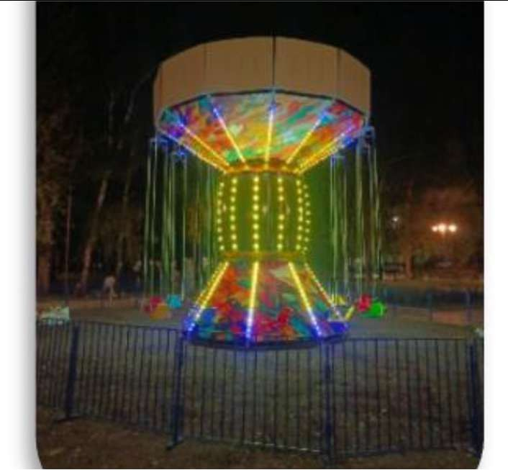
4 | Attraction Orbit | piece | 1 | 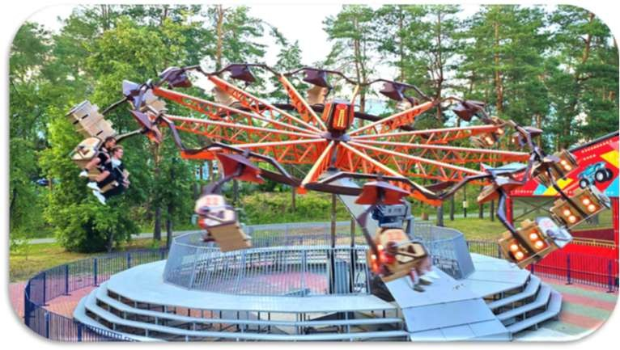  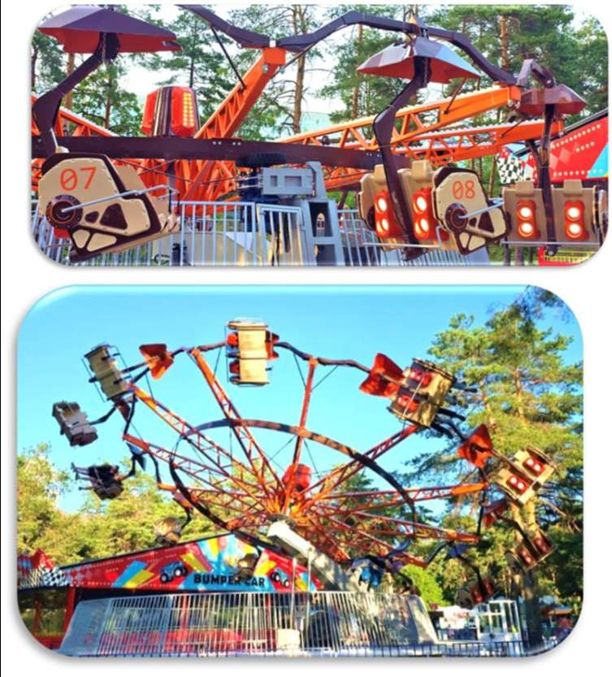

II. CONDITIONS FOR PARTICIPATION IN THE PROCEDURE

2. According to Article 7 of the RA Law "On Procurement", any person, regardless of whether he is a foreign individual, organization or stateless person, has an equal right to participate in the pre-qualification procedure.
3. A participant wishing to participate in the pre-qualification procedure must: meet the qualification criterion "Compliance of professional activity with the activity envisaged by the contract" set out in Article 6, Part 3, Point 1 of the RA Law "On Procurement".Moreover, within the framework of this procurement procedure, the supply of goods equivalent to the goods purchased under this procedure is considered similar.
A participant is considered to meet the qualification criteria set forth in this sub-clause if he/she has submitted the required information with the application:Appendix 2 as defined in this declaration:
4. Participants may participate in the pre-qualification procedure in a joint venture (consortium). In such a case:
1) The pre-qualification application also includes a joint activity agreement.
2) When evaluating the pre-qualification application, the joint qualifications of all members of the joint activity agreement are taken into account (the qualifications of each member of the joint activity agreement must comply with the qualification requirements established by this invitation, assumed by that member under that agreement).
3) participants bear joint and several liability.
4) The party(ies) to the joint activity agreement may not submit separate bid(s) to the same procedure.

5) In the event of a consortium member's withdrawal from the consortium, the contract concluded by the customer with the consortium shall be unilaterally terminated and the liability measures provided for in the contract shall be applied to the consortium members.
5.During the two-stage competition, participants may become aware of or be entrusted with information containing state secrets, the publication of which (in any form) to another person (including relatives) may result in liability as defined by the legislation of the Republic of Armenia..

III. CLARIFICATION IN RECEIVING AND STATEMENT
CHANGE TO PERFORM THE ORDER

6.Participant right has the right to request in writing a clarification regarding the prequalification announcement at least five calendar days before the deadline for submitting prequalification applications.Hthe injection donemto the same person clarification provision is the request in writing? to receive on the day within the next two calendar days.In case of providing information about any participant, the client must ensure that this information is accessible to all potential participants.
If the request referred to in this paragraph is submitted via e-mail, the participant shall send a printed version of the original letter to the e-mail address of the committee secretary:haykhovsepyanhv@mail.ru:
In case the request is submitted via e-mail, a printed version of the original letter regarding its clarification shall be sent to the secretary of the committee by sending the request from the e-mail address provided in this invitation to the participant's e-mail address where the request was received.
7.HThe announcement on the content of the request and clarifications is published in the bulletin on the day the clarification is provided to the participant who made the request, without indicating the data of the participant who made the request, and in the case of procurements containing state secrets, the clarification on the content of the request and clarifications is provided to the participants who received the invitation.
8. Clarification shall not be provided if the request was made in violation of the time limit set forth in this section, as well as if the request is outside the scope of the content of this announcement. Moreover, the participant shall be notified in writing of the grounds for not providing clarification within two calendar days following the date of receipt of the request.
9.Applications presentation deadline upon expiration at least two calendar day forwardin this statementcan are done changes. Change to perform On the first working day following the day of the change, the secretary of the commission to perform about the announcement publicationisnewsletter.
10. In the prequalification statementchanges to be done in caseprequalificationapplications to present deadline counting is that changes about newsletter announcement publication from the day.
IV. PRE-QUALIFICATIONTHE APPLICATION TO PRESENT THE ORDER
11.To participate in this procedure, the participant submits an application to the committee..
12.Prequalification numberThe participant can submit to the committee:
1) electronically, by sending it to the email address provided by this announcement of the Secretary of the Commission:haykhovsepyanhv@mail.ru.
2) in documentary form, in a sealed envelope, sealed. The envelope shall be marked in the language of the prequalification application:
a. the name of the client and the place (address) of submission of the application.
b. procedure code.
c. the words "not to be opened until the bid opening session";
d. the participant's name, location, and telephone number.
13. Applications for the procedure must be submitted to the commission no later than 2:00 p.m. on the 8th day (25.02.2026) from the date of publication of this announcement in the gazette.
Applications that do not meet the requirements of paragraphs 12, 15, 16, 17 and 18 of this instruction will be assessed as unsatisfactory by the commission and will be rejected.
Pre-qualification applications submitted in paper form must be submitted to the commission before the deadline specified in this point, at 26 Baghramyan Street, Aparan, Aragatsotn Region, RA.
14. Pre-qualification applications submitted in paper form are received and registered in the application register by the secretary of the commission.
Applications are registered by the secretary in the register in the order of their receipt, indicating the registration number, date and time in the register. A reference to this is provided upon request by the participant. Applications submitted after the deadline for submitting applications are not registered in the register and are returned by the secretary within two working days following the date of receipt.
15. The participant submits with the pre-qualification application:
1) a written application to participate in the pre-qualification procedure approved by it, in accordance with Appendix N 1,
2) a statement, approved by him, about his compliance with the requirements of the qualification criteria set out in this statement, in accordance with Appendix 2,
3) a copy of the joint activity agreement, if the participants participate in this procedure in a joint activity manner (consortium).
16. If the participant submits a pre-qualification application:
1) in documentary form, then all documents included in the application, except for the document provided for in subparagraph 3 of paragraph 15 of this announcement, are submitted in the original and 3 copies.Documents packages on respectively being written are"original»and"copy»the words:Notarized copies of original documents may be submitted instead of originals..
2) electronically, printed (scanned) versions of the original documents are submitted.
17. Prequalification applications, in addition to Armenian, may also be submitted in English or Russian.
18. The envelope andthisstipulated by the declaration: mAssyrianbydocuments being drawn up signing is them presenting person or the latter authorized person(from now on`agent):Ifprequalificationthe application present is the agent,then by request being presented is the latter that authority reserved to be document about.If appropriate, the participant may submit the required information in forms other than those proposed in this announcement, while maintaining the required requisites.

V. OPENING, EVALUATION AND AWARD OF PRE-QUALIFICATION APPLICATIONS
SUMMARY OF RESULTS

19. The opening, evaluation and summary of the results of the prequalification applications will be held at the prequalification application opening session at 2:00 p.m. on the 8th day from the date of publication of this announcement in the bulletin at 26 Baghramyan Street, Aparan, Aragatsotn Region, RA..
Moreover, the evaluation of applications is carried out at the end of the application submission period.within three business days from the expiration date.
20. At the opening and evaluation session of prequalification applications:
1) hcommittee the secretary information is report in the registry done notes about and commission to the president is transfer applications the register,its inseparable part being the other documents, registeredand/or submitted electronicallyapplications.
2) After the documents specified in subparagraph 1 of this paragraph are transferred to the chairman (chairman of the session), the committee shall evaluate:
a.applications containing the envelopes to make and to present compliance defined okay and opening corresponding evaluated applications.
b.opened each required in the envelope(intended)documents availability and them, as well as those submitted electronicallydocumentscompilation compliancewith this statementdefined to the requirements.
21. Applications that meet the conditions set forth in this announcement are considered satisfactory. Otherwise, pre-qualification applications are considered unsatisfactory and rejected.
If during the pre-qualification application opening sessionresults of the evaluation carried outIf discrepancies are recorded in the participant's application with the requirements of this announcement, the committee shall suspend the session for one working day, and the secretary of the committee shall notify the participant electronically on the same day, proposing to correct the discrepancy before the end of the suspension period. Moreover, the provisions specified in this point:
1) The proposal must describe in detail the recorded discrepancies.
2) The proposal is sent to the participant by sending it from the secretary's email address specified in this announcement to the email address specified in the participant's application.
22. If the participant corrects the recorded discrepancy within the period specified in point 21 of this announcement, then the latter's application is assessed as satisfactory. Otherwise, the application is assessed as unsatisfactory and rejected. The participant shall submit the corrected documents to the e-mail address specified in the application for participation in this procedure.by sending it to the e-mail address provided by the secretary of the meeting.
23. A member or secretary of the commission may not participate in the work of the commission if, during the activities of the commission, it is revealed that an organization founded by the latter or in which they have a share (stock), or a person related to them by close kinship or affinal relationship (parent, spouse, child, brother, sister, grandmother, grandfather, grandson, as well as the spouse's parent, child, brother, sister, grandmother, grandfather, grandson) or an organization founded by that person or in which they have a share (stock) has submitted an application for participation in this procedure. If the condition provided for in this point exists, then the member or secretary of the commission who has a conflict of interest in relation to this procedure shall immediately withdraw from this procedure.
24. A protocol shall be drawn up on the opening, evaluation and summary of the applications, which shall also approve the list of pre-qualified participants. The Secretary of the Commission shall, on the working day following the end of the application session:
1) publishes in the bulletin the original printed (scanned) versions of the declarations of absence of conflict of interest signed by him and the members of the commission present at the bid opening session;
2) notify the participants who submitted applications that were assessed as unsatisfactory in accordance with the conditions provided for in this announcement about the grounds for rejection of the pre-qualification applications.
25. The right to participate in the two-stage process is granted to those participants included in the list of pre-qualified participants who confirm and submit to the Secretary of the Commission, within the period specified in this announcement, the original of the commitment to maintain information containing state secrets. In this regard, the Secretary of the Commission shall simultaneously send a notification from his e-mail address specified in this announcement to the e-mail addresses of the pre-qualified participants specified in the application, indicating the procedure for receiving the invitation. Moreover, the form of the commitment to maintain information containing state secrets and the conditions for filling it out shall also be attached to the notification specified in this point.
Pre-qualified participants shall confirm and, within three working days following the sending of the notification referred to in this point, submit in person to the Secretary of the Commission the original of the undertaking on the protection of information containing state secrets. The Secretary of the Commission shall assess on-site the compliance of the drawn up document with the prescribed form, as well as the identity of the person with the appropriate authority to receive the invitation and, in case of compliance, shall provide the invitation and the relevant reference at the same time, indicating the date and time of issuance of the invitation.
26. Pre-qualified participants who submit documents later than the deadline specified in paragraph 25 of this announcement will not be issued an invitation, and the deadline for submitting applications in two stages is calculated from the day following the expiration of the deadline specified in the same paragraph.
27. The appeal regarding this procedure is carried out in accordance with the procedure established by the RA Law "On Procurement" and the RA Civil Procedure Code.
Moreover, each:
1) an interested person has the right to appeal the actions (inaction) and decisions of the client and the evaluation committee in accordance with the procedure established by the Civil Procedure Code of the Republic of Armenia;
2) Anyone has the right to appeal the requirements of this announcement in accordance with the procedure established by the Civil Procedure Code of the Republic of Armenia before the deadline for submitting applications.
The rates of state fees charged for appeals are set by the Law on State Fees.

For additional information regarding this announcement, you may contact the Secretary of the Commission: H. Hovsepyan:
Phone number:+374 94 23-18-93
Email:haykhovsepyanhv@mail.ru
Client: Aparan Municipality

AppendixNo. 1
ՀՀ-ԱՄ-ԱՀ-ԵՄԱՊՁԲ-07/26pre-qualification for the two-stage competition with the code
procedure statement

APPLICATION*

to participate in the pre-qualification procedure

^{participant name} reports is,that wishes to participate in the two-stage pre-qualification procedure of the Aparan Municipality tender code RA-AM-AR-YEMAPZB-07/26 andprequalification statement requirementsin accordance with the requirements present is application.
^{participant name} -intaxpayer registration numberis` ^{Taxpayer registration number} :
^{participant name} -in electronic mail address is` ^{email address} :

___________________________________________________ _____________ participant name (leader position, anun last name) signature

K.T.

AppendixNo. 2
ՀՀ-ԱՄ-ԱՀ-ԵՄԱՊՁԲ-07/26pre-qualification for the two-stage competition with the code
procedure statement

ANNOUNCEMENT
"Professional" activity compliance by contract
intended "activity"qualificationstandard of care about

^{participant name} declares and confirms thatto submit the applicationDuring the year and the years preceding it, the above-mentioned goods were supplied:

Contracts duly executed during the year of submitting the prequalification application and the years preceding it
h/h | the subject | Customer and contact details
The year is: ............ year
1
2
...
The year is: ............ year
1
2
...
The year is: ............ year
1
2
...

___________________________________________________ _____________ participant name (leader position, anun last name) signature

K.T.

